WEEK 35:

TEST 1

A – LOOK AT THE PICTURE AND WRITE “YES” OR “NO”:

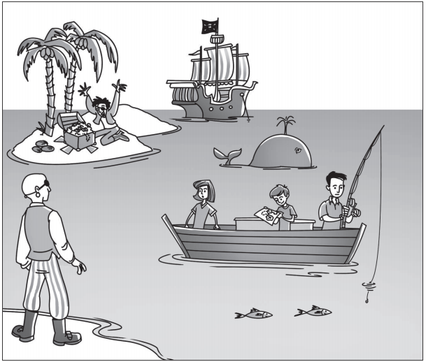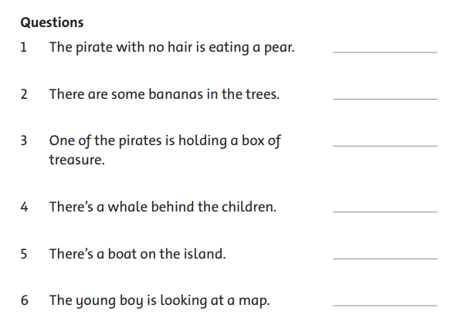

B – READ AND CICLE:

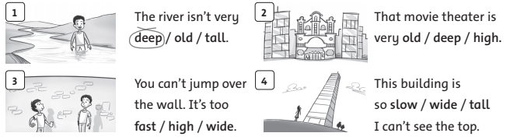

C – LOOK AND CIRCLE:

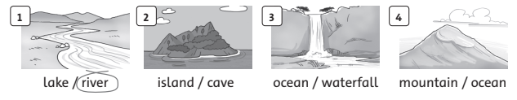

TEST 2

A – READ AND TICK (🗹):

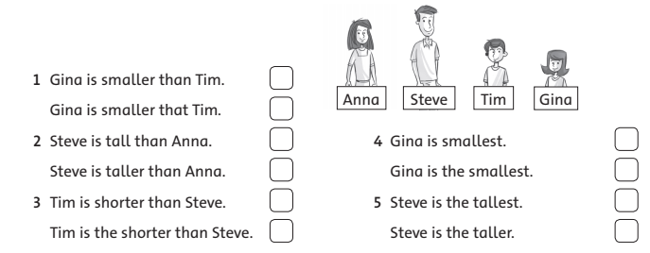

B – WRITE “MUST” OR “MUSTN’T”:

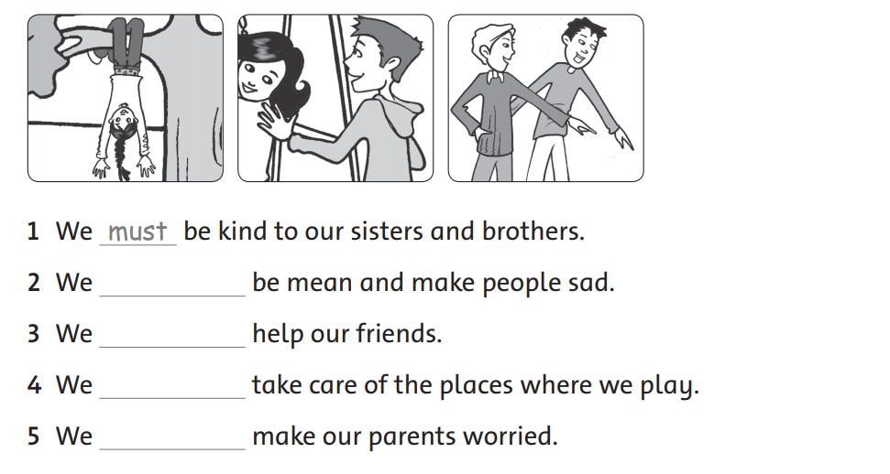

C – LOOK AND CIRCLE:

